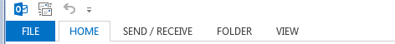
- Select [File]

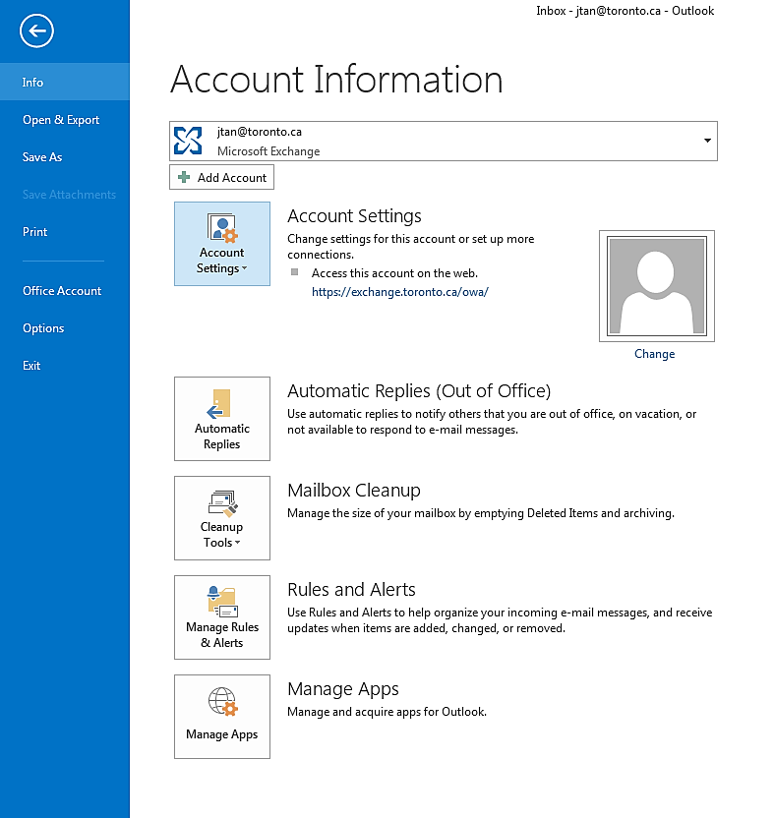

- Select [Account Settings]

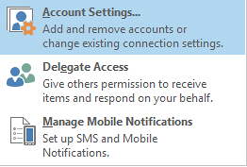
- Select [Account Settings] from drop down

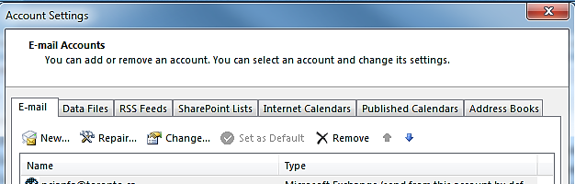

- Select [New]

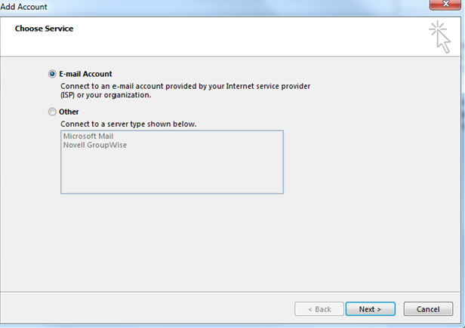
- Select [E-mail Account] then [Next]

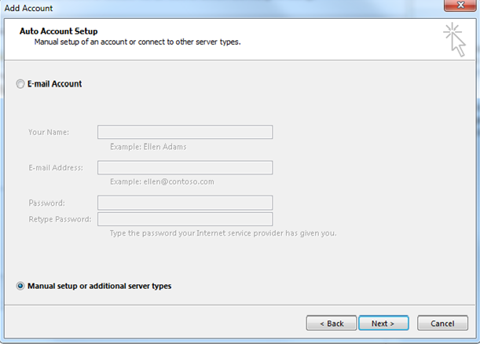

- Check [Manual setup or additional server types] then [Next]
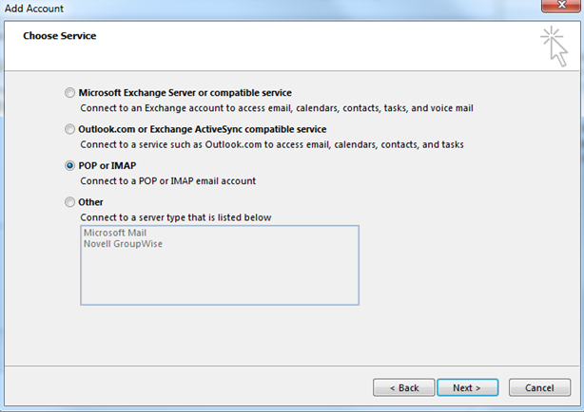

- Select [POP or IMAP] then [Next]

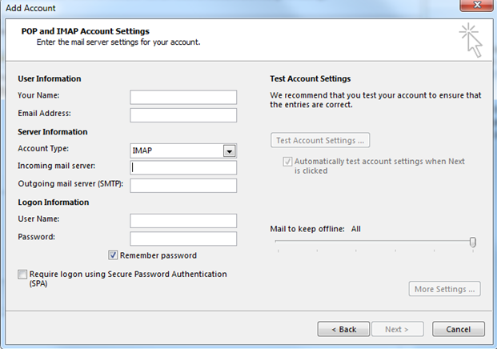

Populate the following
User Information
- Your Name: [First Name Last Name]
- Email Address: [novellid@toronto.ca]
Server Information
- Account Type: Select [IMAP] from drop down menu
- Incoming mail server:
  - If you dial 29900, 29099, 70709, 24233, 24511, 56940 or 64764 to access your voice mail enter [vmail1.toronto.ca]
  - If you dial 24111, 26000, or 42585 to access your voice mail enter [vmail2.toronto.ca]
- Outgoing mail server (SMTP): [add the same information as you did above for the incoming mail server]
Logon Information
- User Name: [Novell ID]
- Password: [Novell password]
- Then select [Next]
- Then select [Close]
- Congratulations you have finished installing IMAP!
- The Voice Mail [IMAP] folder will now appear as a separate folder similar to your email folder, expand the folder and select Inbox to display any voice mail messages archived and/or new.

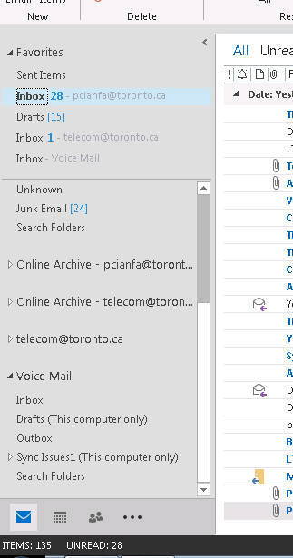

If you prefer to differentiate between Inboxes for both Email and Voice Mail, you can rename your IMAP folder 'Voice Mail'.

Here is how to do so…..

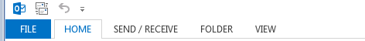

- Select [File]

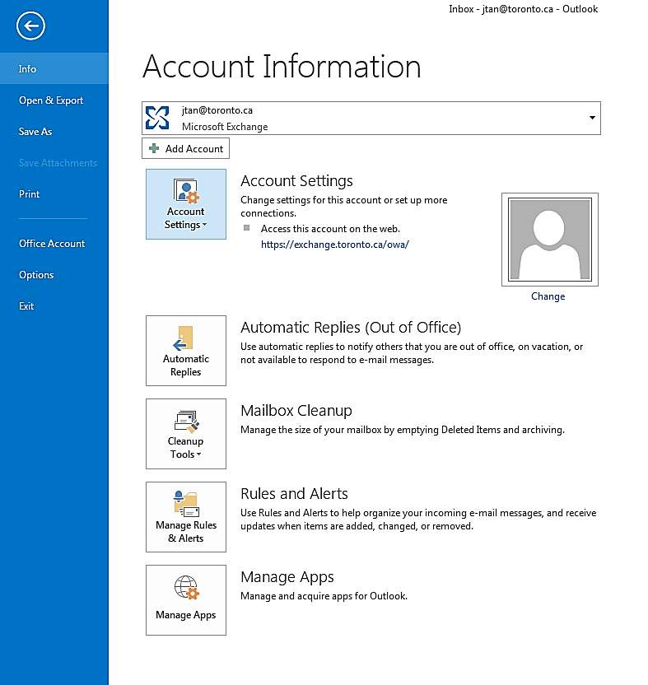
- Select [Account Settings]

- Select [Account Settings] from drop down

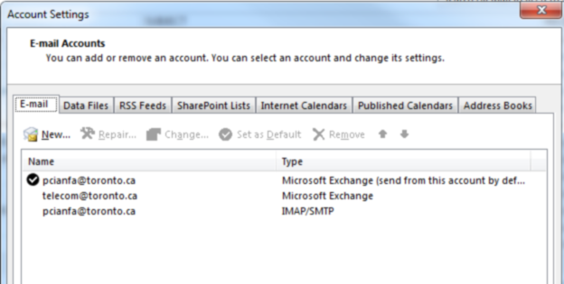

- Double click on your newly established [IMAP Account]

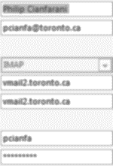
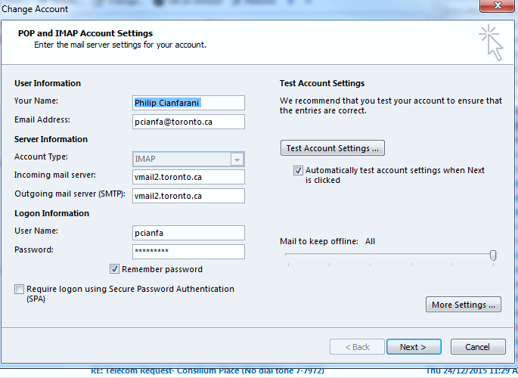
- Click on [More Settings]

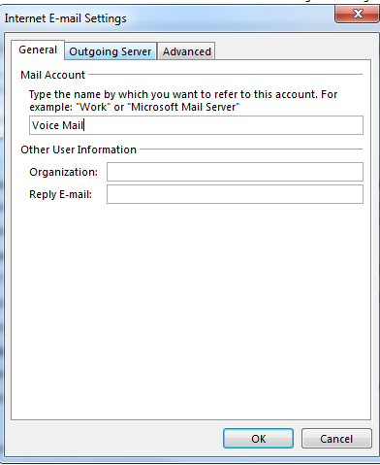

[General | Mail Account]
Delete the existing email address (populated when IMAP account was created) and rename the folder:
'Voice Mail'

- After renaming click [OK]
- Then select [Next]
- Then select [Close]

Instructions for users who access Shared Mailboxes Only:

User Information
- Your Name: [Shared name ie. Telecom Group]
- Email Address: [enter the 10 digit extension of the shared mail box followed by mb@vmail1.toronto.ca 29900, 29099, 29099, 70709, 24233, 24511, 56940 or 64764 to access your voice mail enter or followed by mb@vmail2.toronto.ca If you dial 24111, 26000, or 42585 to access your voice mail]
[ie. 4161111111mb@vmail1.toronto.ca or 4161111111mb@vmail2.toronto.ca]

Server Information
- Account Type: Select [IMAP] from drop down menu
- Incoming mail server:
  - If you dial 29900, 29099, 29099, 70709, 24233, 24511, 56940 or 64764 to access your voice mail enter [vmail1.toronto.ca]
  - If you dial 24111, 26000, or 42585 to access your voice mail use [vmail2.toronto.ca]
- Outgoing mail server (SMTP): [add the same information as you did above for the incoming mail server]

Logon Information
- User Name: [enter the 10 digit extension of the shared mail box followed by mb – ie. 4161111111mb]
- Password: [contact Telecom Co-ordinator]

Congratulations you have finished installing a shared IMAP folder.

The Voice Mail folder will now appear as a separate folder, selecting the Inbox will display voice mail messages.

Organizing and Saving your Voice Mail
When you open an attachment, in your Voice Mail [Inbox] folder, to listen to a voice mail message, Outlook directly connects to the voice mail server to retrieve the voice mail message in .wav format.
If you would like to save any of your voice mail messages, you can save them to a network drive.
- Via Voice Mail folder, click on the email with attached voice message.
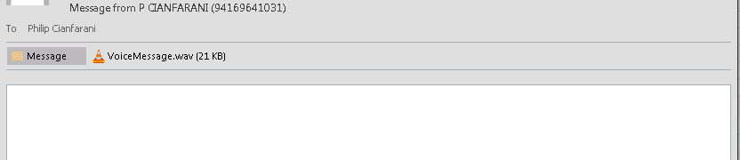
- [Right Click] on the voice message and select [Save As]
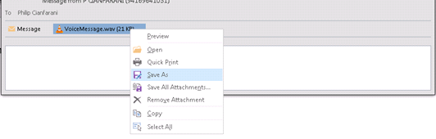
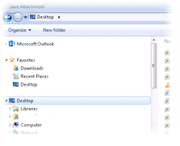
- In the [Save As] window navigate to the folder where you would like to save the message to and open that folder.

- In the [File Name] line, change the file name from the default [VoiceMessage.wav] to something unique. The file name could be in the following format, 10 digit phone number-month-day-yyyy.wav [4163382109-10-11-2015.wav] or 5 digit extension number-month-day-yyyy.wav [ 82109-10-11-2015.wav]
- The phone number or extension number can be found in brackets in the original emails subject line, unless message is from an unknown sender.
In this case you would have to listen to the message before archiving in order to name it appropriately.

A Quick shortcut for archiving
If you do not archive messages on a regular basis however may need to on rare occasion - a quick way to do so is to drag and drop entire email with attached voice mail from Voice Mail folder over to a shortcut folder [mapped to a network drive] on your desktop. This will automatically create a sub folder with file name containing the name and telephone number of the voice mail message.
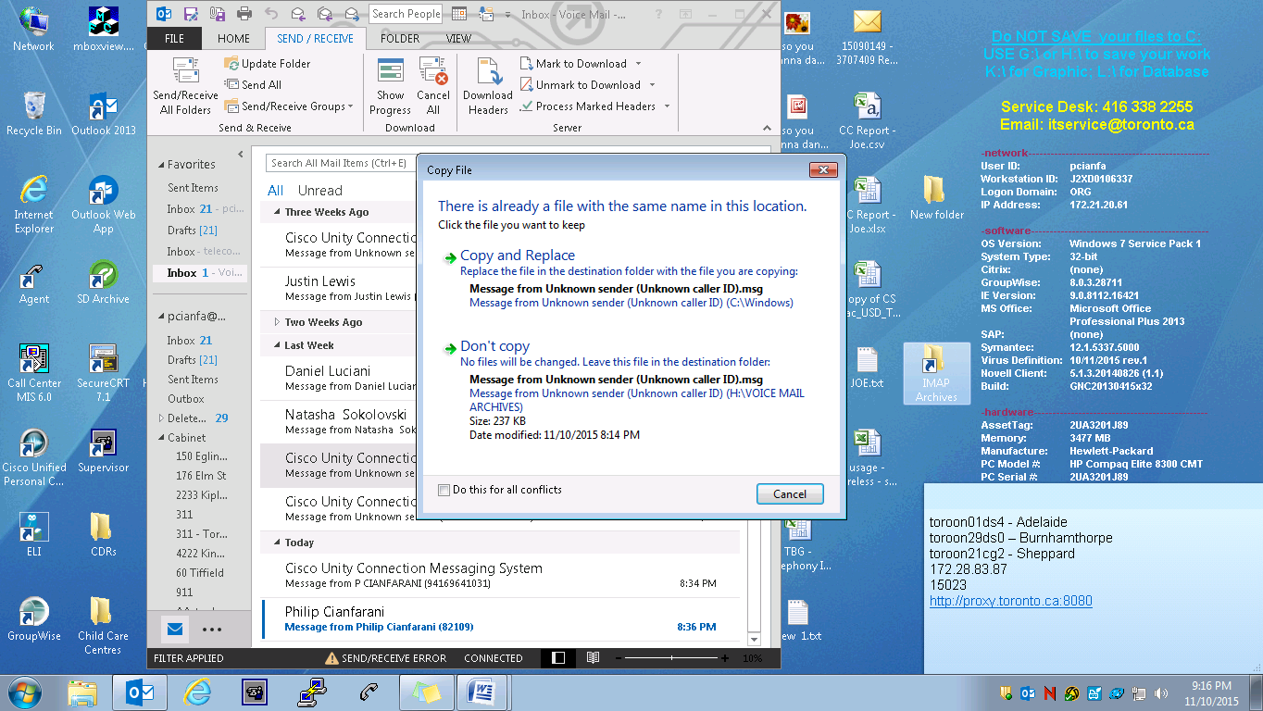
Please note, this would only apply to messages received from different senders as doing so from the same sender will only give you options to either [Copy and Replace] or [Don't Copy]

To prevent this from happening – be sure to highlight all messages from the same caller on the same day and drag all into a separate folder – this will then automatically number each to avoid duplicate file names.

